Section 10-1: Circles and Circumference

SOL: G.10 The student will investigate and solve practical problems involving circles, using properties of angles, arcs, chords, tangents, and secants. Problems will include finding arc length and the area of a sector, and may be drawn from applications of architecture, art, and construction.

Objective:
Identify and use parts of circles
Solve problems involving the circumference of a circle

Vocabulary:
Circle – the locus (set) of all points in a plane equidistant for a given point
Center – the central point of a circle
Chord – any segment that endpoints are on the circle
Diameter – a chord that passes through the center of the circle
Radius – any segment that endpoints are the center and a point on the circle

Key Concepts:

Diameter (d) is twice the radius (r): d = 2r
Circumference (C): C = 2πr = dπ
Concept Summary:
Diameter of a circle is twice the radius
Circumference, C, of a circle with diameter, d, or a radius, r, can be written in the form
C = πd or C = 2πr

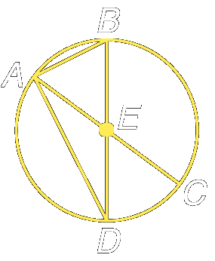
Example 1:
- Name the circle
- Name the radius of the circle
- Name a chord of the circle
- Name a diameter of the circle

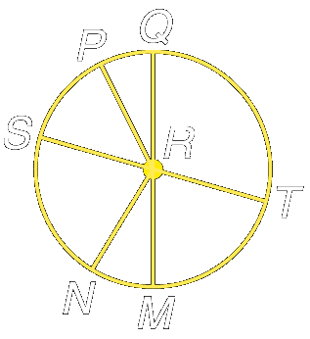
Example 2: Circle R has diameters ST and QM
- If ST = 18, find RS
- If RM = 24, find QM
- If RN = 2, find RP

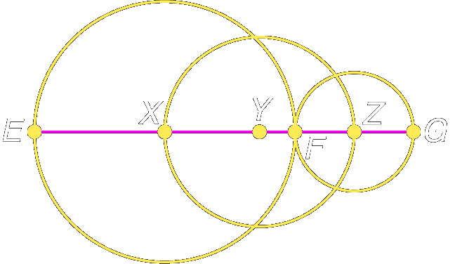
Example 3: The diameters of Circle X, Circle Y and Circle Z are 22 millimeters, 16 millimeters, and 10 millimeters, respectively.
a) Find EZ

b) Find XF

Example 4:
- Find C if r = 22 centimeters
- Find C if d = 3 feet
- Find d and r to the nearest hundredth if C = 16.8 meters

Homework: pg 526-527; 16-20, 32, 33, 44-47
Section 10-2: Angles and Arcs

SOL: G.10 The student will investigate and solve practical problems involving circles …. .

Objective:
Recognize major arcs, minor arcs, semicircles, and central angles and their measures
Find arc length

Vocabulary:
Central Angle – has the center of the circle as its vertex and two radii as sides
Arc – edge of the circle defined by a central angle
Minor Arc – an arc with the central angle less than 180° in measurement
Major Arc – an arc with the central angle greater than 180° in measurement
Semicircle – an arc with the central angle equal to 180° in measurement
Arc Length – part of the circumference of the circle corresponding to the arc

Theorems:
Theorem 10.1: In the same or in congruent circles, two arcs are congruent if and only if their corresponding central angles are congruent.
Postulate 10.1, Arc Addition Postulate: The measure of an arc formed by two adjacent arcs is the sum of the measures of the two arcs.

Key Concepts:
The sum of central angles measures of a circle with no interior points in common is 360°

Arc length Degree Measure of Arc l A
------------------ = ------------------------------- ------ = ------
Circumference Degree Measure of Circle 2πr 360

Concept Summary:
Sum of measures of central angles of a circle with no interior points in common is 360°
Measure of each arc is related to the measure of its central angle
Length of an arc is proportional to the length of the circumference

Example 1: Given Circle T with RV as a diameter, find
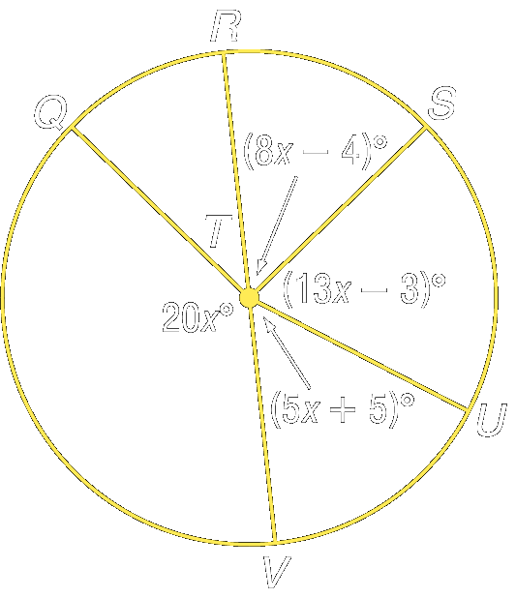
- m∠RTS
- m∠QTR
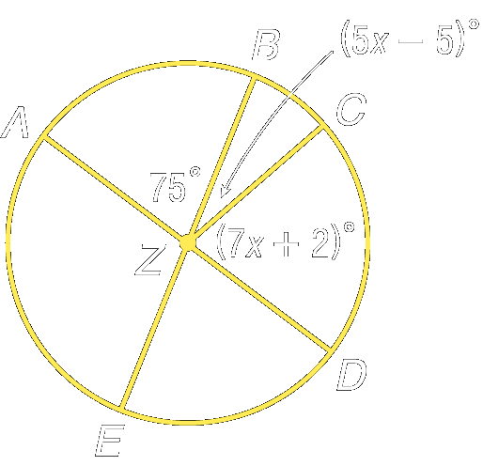
Example 2: AD and BE are diameters
- m∠CZD
- m∠BZC

Example 3: In circle P, m∠MNP = 46°, PL bisects ∠KPM and OP ⊥ KN
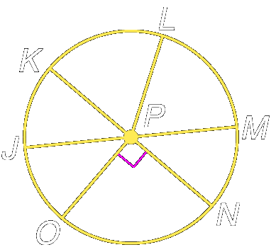
- Find m arc OK
- Find m arc LM
- Find m arc JKO

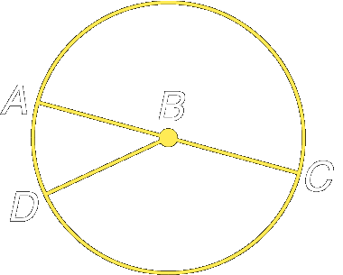
Example 4:
- In circle B, AC = 9 and m∠ABD = 40, find the length of arc AD

- Find the length of arc DC

Homework: pg 533-534; 14-19; 24-29; 32-35
Section 10-3: Arcs and Chords

SOL: G.10 The student will investigate and solve practical problems involving circles, using properties of angles, arcs, chords, tangents, and secants. Problems will include finding arc length and the area of a sector, and may be drawn from applications of architecture, art, and construction.

Objective:
Recognize and use relationships between arcs and chords
Recognize and use relationships between arcs and diameters

Vocabulary:
Inscribed Polygon – all vertices lie on the circle
Circumscribed – circle contains all vertices of a polygon

Theorems:
Theorem 10.2: In a circle or in congruent circles, two minor arcs are congruent if and only if their corresponding chords are congruent.
Theorem 10.3: In a circle, if a diameter (or radius) is perpendicular to a chord, then it bisects the chord and its arc.
Theorem 10.4: In a circle or in congruent circles, two chords are congruent if and only if they are equidistant from the center.


Concept Summary:
The endpoints of a chord are also the endpoints of an arc
Diameters perpendicular to chords bisect chords and intercepted arcs

Example 1: The rotations of a tessellation can create twelve congruent central angles. Determine whether arc PQ is congruent to arc ST.

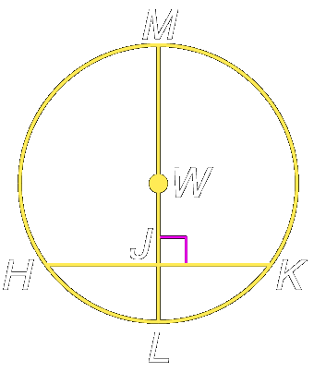
Example 2: Circle W has a radius of 10 centimeters. Radius WL is perpendicular to chord HK which is 16 centimeters long.
- If m arc HL = 53, then find m arc MK
- Find JL

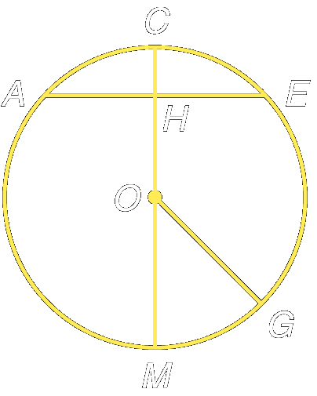
Example 3: Circle O has a radius of 25 units. Radius OC is perpendicular to chord AE which is 40 units long.
- If m arc MG = 35, then find m arc CG
- Find CH
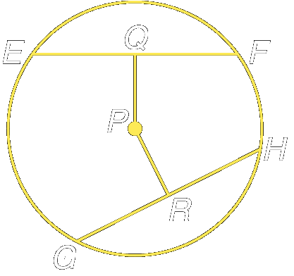

Example 4: Chords EF and GH are equidistant from the center. If the radius of circle P is 15 and EF = 24, find PR and RH.

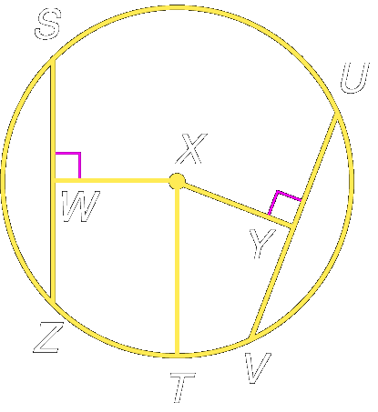
Example 5: Chords SZ and UV are equidistant from the center of circle X. If TX is 39 and XY is 15, find WZ and UV.

Homework: pg 540-543; 11-18; 30-33, 52
Section 10-4: Inscribed Angles

SOL: G.10 The student will investigate and solve practical problems involving circles, using properties of angles, arcs, chords, tangents, and secants. Problems will include finding arc length and the area of a sector, and may be drawn from applications of architecture, art, and construction.

Objective:
Find measures of inscribed angles
Find measures of angles of inscribed polygons

Vocabulary:
Inscribed Angle – an angle with its vertex on the circle and chords as its sides

Theorems:
Theorem 10.5: If an angle is inscribed in a circle, then the measure of the angle equals one-half the measure of its intercepted arc (or the measure of the intercepted arc is twice the measure of the inscribed angle).
Theorem 10.6: If two inscribed angles of a circle (or congruent circles) intercept congruent arcs or the same arc, then the angles are congruent.
Theorem 10.7: If an inscribed angle intercepts a semicircle, the angle is a right angle.
Theorem 10.8: If a quadrilateral is inscribed in a circle, then its opposite angles are supplementary.

Concept Summary:
The measure of the inscribed angle is half the measure of its intercepted arc
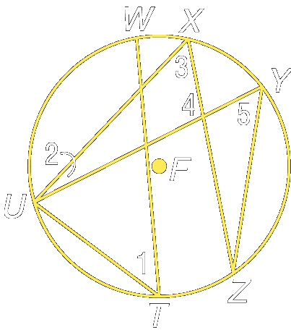
The angles of inscribed polygons can be found by using arc measures

Example 1: In circle F, m arc WX = 20, m arc XY = 40, m arc UZ = 108 and m arc UW = m arc YZ. Find the measures of the numbered angles

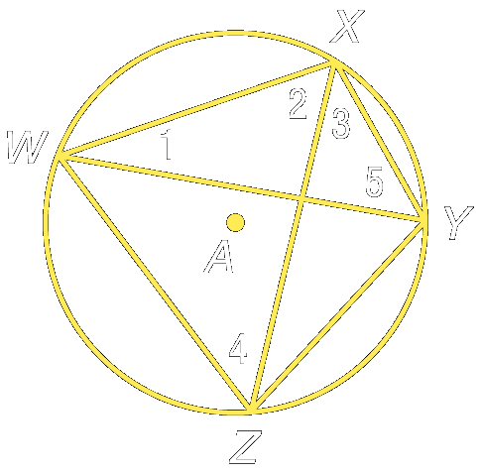
Example 2: In circle A, m arc XY = 60, m arc YZ = 80, and m arc WX = m arc WZ. Find the measures of the numbered angles

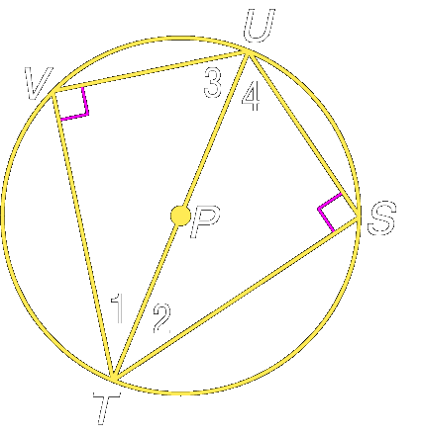

Example 3: Triangles TVU and TSU are inscribed in circle P with arc VU ≅ arc SU. Find the measure of each numbered angle if m∠2 = x + 9 and ∠4 = 2x + 6.

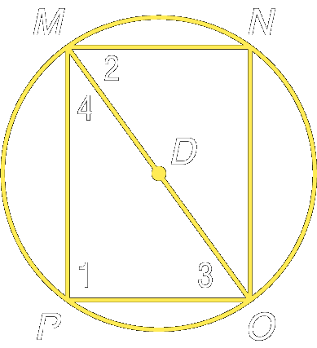
Example 4:

Example 5: Quadrilateral QRST is inscribed in circle M. If m∠Q = 87°, and m∠R = 102°.
Find m∠S and m∠T.
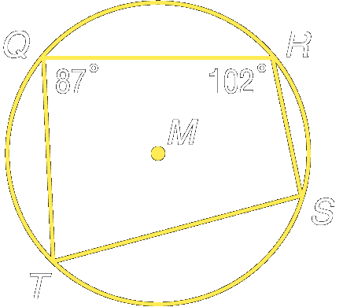

Example 6: Quadrilateral BCDE is inscribed in circle X. If m∠B = 99°, and m∠C = 76°.
Find m∠D and m∠E.

Homework: pg 549-550; 7, 9,10, 15, 22-25,
Section 10-5: Tangents

SOL: G.10 The student will investigate and solve practical problems involving circles, using properties of angles, arcs, chords, tangents, and secants. Problems will include finding arc length and the area of a sector, and may be drawn from applications of architecture, art, and construction.

Objective:
Use properties of tangents
Solve problems involving circumscribed polygons

Vocabulary:
Tangent – a line that intersects a circle in exactly one point
Point of tangency – point where a tangent intersects a circle

Theorems:
Theorem 10.9: If a line is tangent to a circle, then it is perpendicular to the radius drawn to the point of tangency.
Theorem 10.10: If a line is perpendicular to a radius of a circle at its endpoint on the circle, then the line is tangent to the circle. (forms a biconditional statement with Thrm 10.9)
Theorem 10.11: If two segments from the same exterior point are tangent to a circle, then they are congruent.

Concept Summary:
A line that is tangent to a circle intersects the circle in exactly one point.
A tangent is perpendicular to a radius of a circle
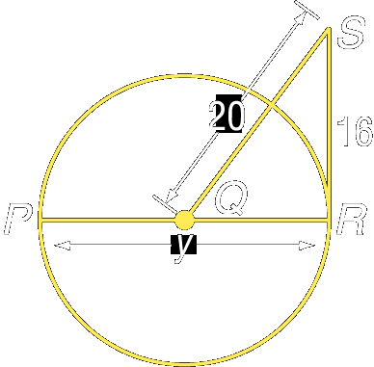
Two segments tangent to a circle form the same exterior point are congruent

Example 1: RS is tangent to circle Q at point R. Find y

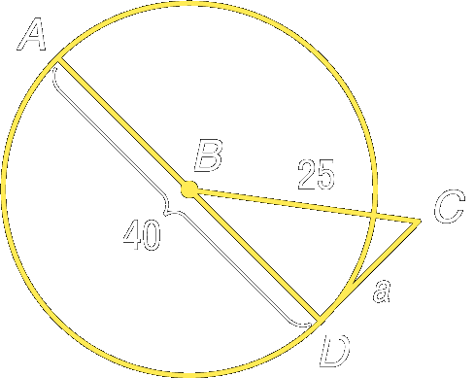
Example 2: CD is tangent to circle B at point D. Find a

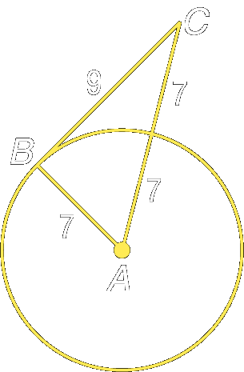
Example 3: Determine whether BC is tangent to circle A

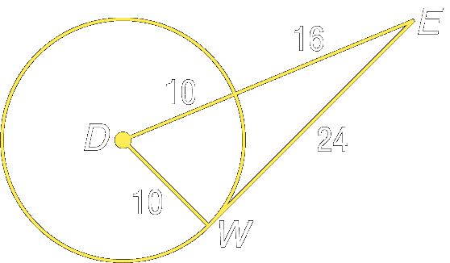
Example 4: Determine whether EW is tangent to circle D

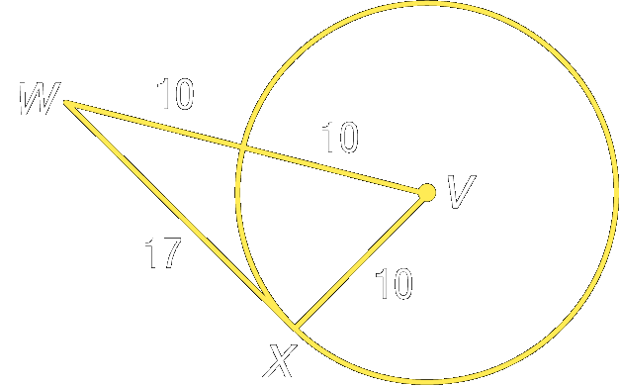
Example 5: Determine whether WX is tangent to circle V

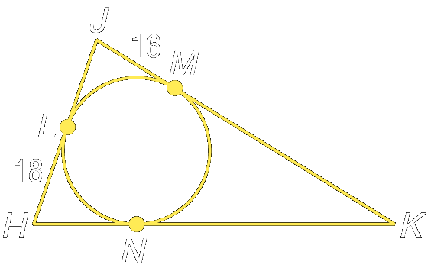
Example 5: Triangle HJK is circumscribed about circle G. Find the perimeter of ΔHJK if NK = JL + 29.

Homework: pg 556-558; 8-11, 12-17
Section 10-6: Secants, Tangents, and Angle Measures

SOL: G.10 The student will investigate and solve practical problems involving circles, using properties of angles, arcs, chords, tangents, and secants. Problems will include finding arc length and the area of a sector, and may be drawn from applications of architecture, art, and construction.

Objective:
Find measures of angles formed by lines intersecting on or inside a circle
Find measures of angles formed by lines intersecting outside a circle

Vocabulary:
Secant – a line that intersects a circle in exactly two points

Theorems:
Theorem 10.12: If two secants intersect in the interior of a circle, then the measure of an angle formed is one-half the sum of the measure of the arcs intercepted by the angle and its vertical angle.
Theorem 10.13: If a secant and a tangent intersect at the point of tangency, then the measure of each angle formed is one half the measure of its intercepted arc
Theorem 10.14: If two secants, a secant and a tangent, or two tangents intersect in the exterior of a circle, then the measure of the angle formed is one-half the positive difference of the measures of the intercepted arcs.

Concept Summary:
The measure of an angle formed by two secant lines is half the positive difference of its intercepted arcs
The measure of angle formed by a secant and tangent line is half its intercepted arc
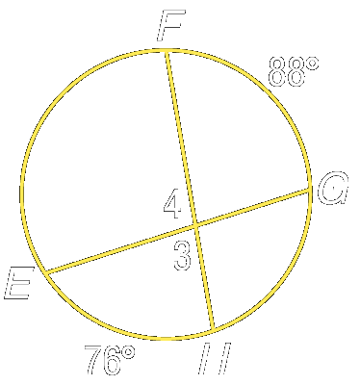
Example 1: Find the m∠4, if m arc FG = 76 and m arc GH = 88

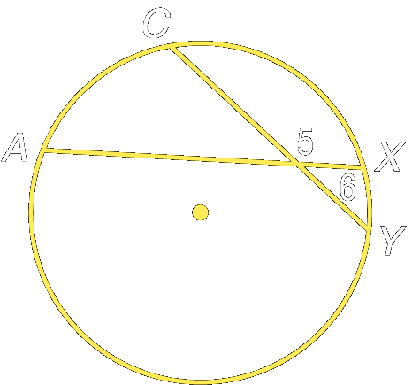
Example 2: Find the m∠5, if m arc AC = 63 and m arc XY = 21

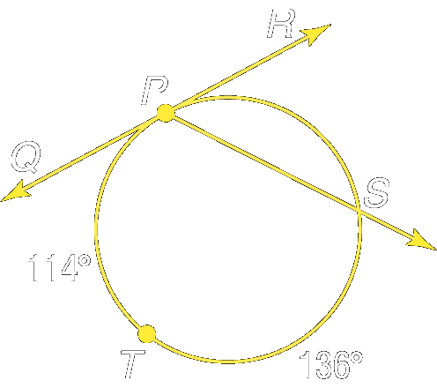
Example 3: Find ∠RPS, if m arc PT = 114 and m arc TS = 136

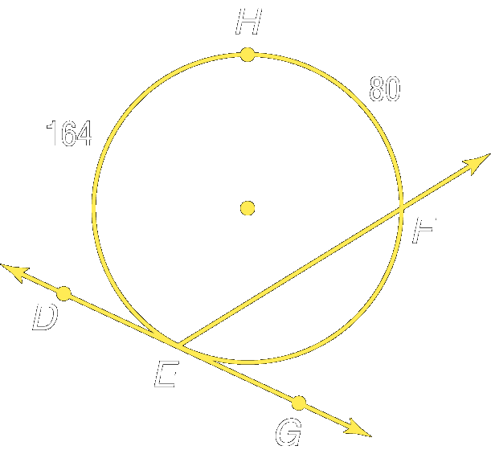

Example 4: Find ∠RPS, if m arc PT = 114 and m arc TS = 136

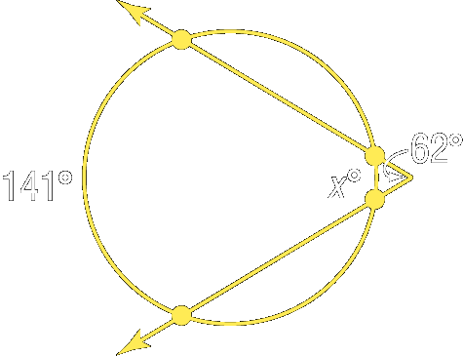
Example 5: Find x

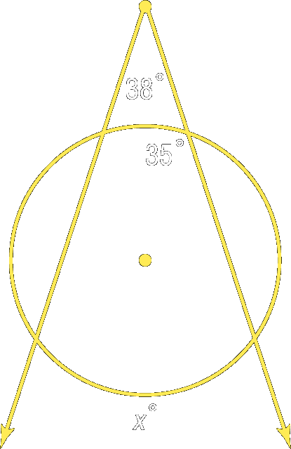
Example 6: Find x

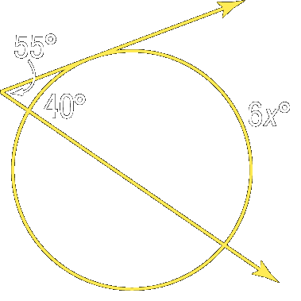
Example 7: Find x

Homework: pg 564-566; 12-14, 18-20; 23-24, 26, 29, 34-36
Section 10-7: Special Segments in a Circle

SOL: G.10 The student will investigate and solve practical problems involving circles, using properties of angles, arcs, chords, tangents, and secants. Problems will include finding arc length and the area of a sector, and may be drawn from applications of architecture, art, and construction.

Objective:
Find measures of segments that intersect in the interior of a circle
Find measures of segments that intersect in the exterior of a circle

Vocabulary: None New

Theorems:
Theorem 10.15: If two chords intersect in a circle, then the products of the measures of the segments of the chords are equal.
Theorem 10.16: If two secant lines are drawn to a circle from an exterior point, then the product of the measures of one secant segment and its external secant segment is equal to the product of the measures of the other secant segment and its external secant segment
Theorem 10.17: If a tangent segment and a secant segment are drawn to a circle from an exterior point, then the square of the measure of the tangent segment is equal to the product of the measures of the secant segment and its external secant segment.

Concept Summary:
The lengths of intersecting chords in a circle can be found by using the products of the measures of the segments
The secant segment product also applies to segments that intersect outside the circle, and to a secant segment and a tangent

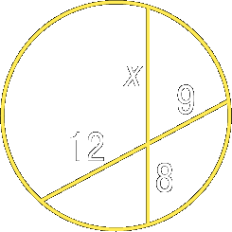
Example 1: Find x

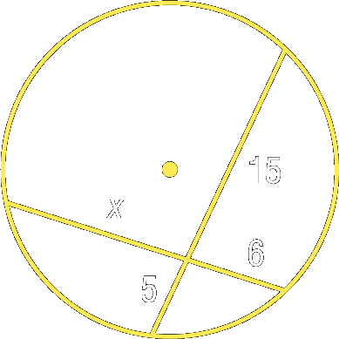
Example 2: Find x

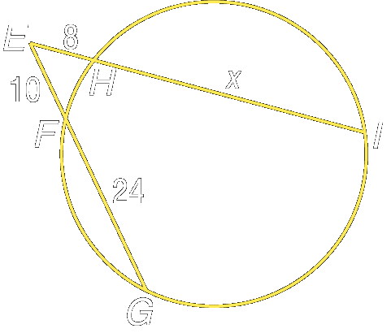
Example 3: Find x, if EF = 10, EH = 8, and FG = 24.

Example 4: Find x if GO = 27, OM = 25 and IK = 24.

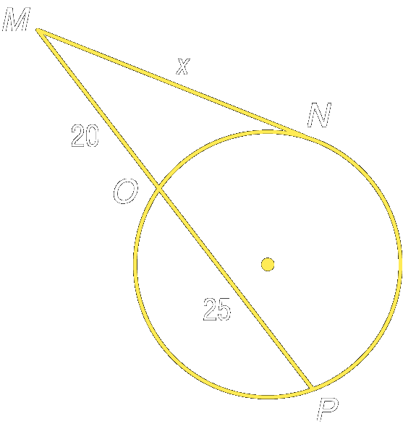

Homework: pg 572 – 573; 8-10; 13-17; 22-24
Section 10-8: Equations of Circles

SOL: G.10 The student will investigate and solve practical problems involving circles, using properties of angles, arcs, chords, tangents, and secants. Problems will include finding arc length and the area of a sector, and may be drawn from applications of architecture, art, and construction.

Objective:
Write the equation of a circle
Graph a circle on the coordinate plane

Vocabulary: None New

Key Concepts:

Concept Summary:
The coordinates of the center of a circle (h, k) and its radius r can be used to write an equation for the circle in the form (x – h)² + (y – k)² = r²
A circle can be graphed on a coordinate plane by using the equation written in standard form
A circle can be graphed through any three noncollinear points on the coordinate plane

Example 1: Write an equation for a circle with the center at (3, –3), d = 12.

Example 2a: Write an equation for each circle with center at (0, –5), d = 18.

Example 2b: Write an equation for a circle with the center at (7, 0), r = 20.

Homework: pg 578; 10-17, 25-27
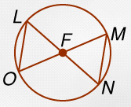
Lesson 10-1 5-Minute Check:
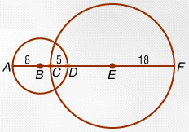
Refer to ⊙F.
- Name a radius
- Name a chord
- Name a diameter

Refer to the figure and find each measure
4. BC
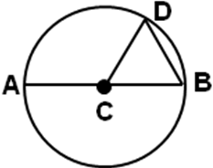
5. DE
6. Which segment in ⊙C is a diameter?
A. AC B. CD C. CB D. AB

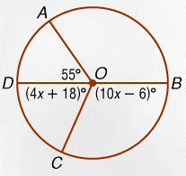
Lesson 10-2 5-Minute Check:
In ⊙O, BD is a diameter and m∠AOD =55°. Find each measure.
- m∠COB
- m∠DOC
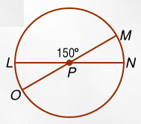
- m∠AOB
Refer to ⊙P. Find each measure.
4. m arc LM
5. m arc MOL
6. If the measure of an arc is 68°, what is the measure of its central angle?
A. 34° B. 68° C. 102° D. 136°

Lesson 10-3 5-Minute Check:
The radius of ⊙R is 35, LM ≅ NO, LM = 45 and m arc LM = 80.
Find each measure.
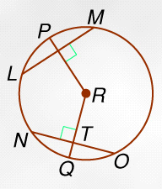
- m arc NO
- m arc NQ
- NO
- NT
- RT
- Which congruence statement is true if RS and TU are congruent chords of ⊙V?
A. RS ≅ SU B. RS ≅ TU C. ST ≅ RU D. RS ≅ ST

Lesson 10-4 5-Minute Check:
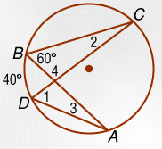
Refer to the figure and find each measure.
- m∠1
- m∠2
- m∠3
- m∠4
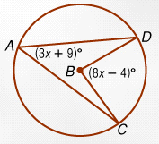
- In ⊙B, find x if m∠A = 3x + 9 and m∠B = 8x – 4.

- If an inscribed angle has a measure of 110, what is the measure of its intercepted arc?
A. 55 B. 70 C. 110 D. 220

Lesson 10-5 5-Minute Check:
Determine whether each segment is tangent to the given circle.
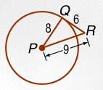
- BC 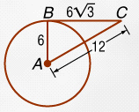 2. QR
Find x. Assume that the segments that appear to be tangents are tangents.
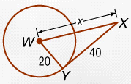
3. 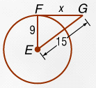 4.
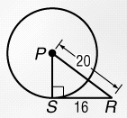
5. What is the measure of PS?
A. 10 B. 12 C. 14 D. 18

Lesson 10-6 5-Minute Check:
Find x. Assume that any segment that appears to be tangent is tangent.
- 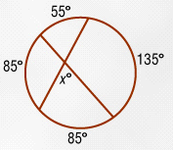 2. 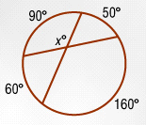
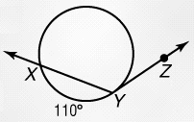
3. 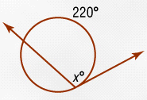 4. 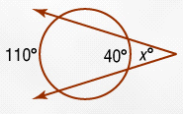
5. What is the measure of ∠XYZ if YZ is tangent to the circle?
A. 55 B. 70 C. 125 D. 250

Lesson 10-7 5-Minute Check:
Find x.
- 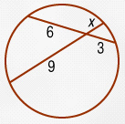 2. 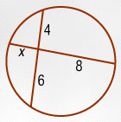
3. 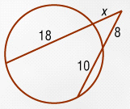 4. 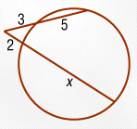
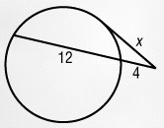
5. Find x in the figure
A. 6 B. 8 C. 12 D. 16

